

EMERGENCY

PROCEDURES

(Updated February 16, 2024)

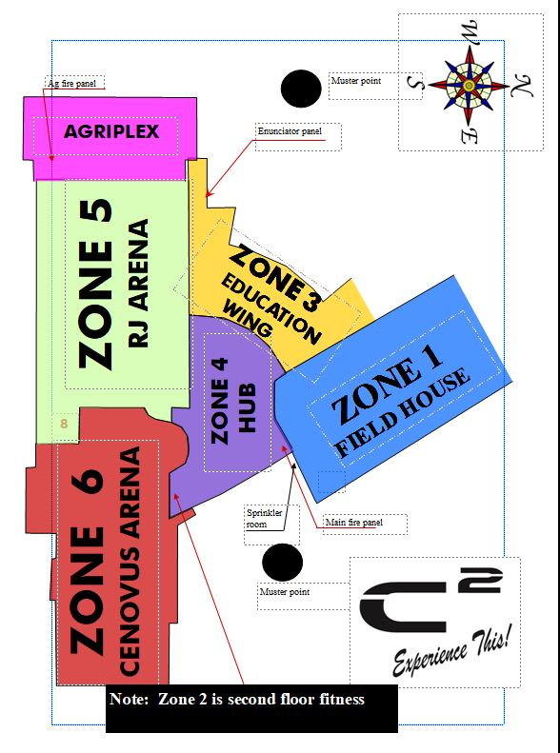

Fire/Evacuation Procedure Training Sheet

If the alarm sounds:

- IF THE BUILDING ALARM HAS BEEN ACTIVATED, there will be an automatic response sent to the fire department.
- CLEAR YOUR IMMEDIATE AREA. Patrons will leave out the closest exit to the muster points (unless dangerous to do so – then exit where safe and go to the muster point). DO NOT USE THE ELEVATOR.
- ALL STAFF MUST CHECK IN AT THE WELCOME DESK WITH RADIOS IF SAFE TO DO SO. Otherwise exit whichever door you can safely get out of, and then make your way back to the East Muster Point, and wait for further instructions from the Incident Commander or the onsite Fire Marshall.
- If THERE ARE NO MANAGERS ON SHIFT (GM or designate typically is Incident Commander & Ops Manager or designate is typically Lead Responder), Senior Welcome Desk staff will substitute as Incident Commander until the first Manager or Supervisor arrives on site. They must remain at the desk (unless dangerous to do so) to answer the call from the Fire Department. They will also assign other staff members to the following:
  - Senior Staff Member on duty at the Welcome Desk will get the emergency procedures, and go to the fire Alarm Box to retrieve keys and zone maps.
  - STAFF must report to the Welcome Desk and sign in.
  - LOCATE fire panel to find alarm message.
  - TWO STAFF will check the area marked on the panel for fire, heat and/or unusual smoke with the appropriate keys. They will maintain radio contact with Lead Responder.
  - STAFF WILL PAIR UP, be given a radio, be assigned zones and given keys to check the building for other people, getting everyone to meet at one of the two muster points. They must maintain radio contact with the incident commander.
  - ONCE ROOMS are checked, doors must be closed, left unlocked and lights left on.
- THE INCIDENT COMMANDER will meet the emergency response team at the fire control panel in the main entrance of the Centennial Centre.
- ONE STAFF will be sent to each muster point with a radio
- DO NOT RE-ENTER THE BUILDING FOR ANY REASON until the fire department determines it is safe to do so.
If you discover the fire:

- REPORT it to the Incident Commander.
- ATTEMPT TO EXTINGUISH THE FIRE-IF, and only IF, the fire is still small and confined and you feel you can do so without risk to your personal safety. Make sure you use the fire extinguisher.
- IF ATTEMPT to extinguish fails, back away from the fire, close the door (if possible) to contain the fire and evacuate immediately. No staff person will be expected to perform these duties unless they feel comfortable and safe with the procedure.
- DO NOT attempt to save any possessions at the risk of personal injury.
- CHECK FOR heat if doors are closed. Find an alternate route if the doors are hot.
- STAY LOW if moving through smoke as it may be toxic.
- REPORT to the east muster point outside the building and wait for further instructions from the Incident Commander or the onsite Fire Marshal.
Fire Extinguishers - Operation

- Ensure you have a safe exit.

- Stand back 5 to 10 feet for safety and to avoid material being blown away by extinguishers’ pressure

- PASS Pull pin (handle must not be squeezed)
Aim at base of flame
Squeeze gently
Sweeping motion
(10 to 30 seconds of available extinguishment)
Wait to ensure non-re-ignition

FOUND CHILD PROCEDURE
- IF A CHILD IS FOUND ALONE IN THE BUILDING it must first be established if the parent or guardian is in the building, by speaking with the child. Get the child’s name and parents name if possible.
- IF THE PARENT OR GUARDIAN IS NOT LOCATED IMMEDIATELY, accompany the child to the Welcome Desk. At this point the Senior Staff Member on duty at the Welcome Desk will be asked to assist with the child. (Buddy System)
- DO NOT GIVE THE CHILD ANYTHING TO EAT OR DRINK
- WELCOME DESK STAFF will use the PA system to ask the parent or guardian to come to the front desk. When they arrive, explain the C2’s policy that all children under the age of 8 must be accompanied by an adult at all times.
- IF NO ONE SHOWS UP TO CLAIM THE CHILD the RCMP must be called.

MISSING / LOST CHILD PROCEDURE
- IF SOMEONE REPORTS A MISSING OR LOST CHILD it must first be established if the child is presumed to be in the building and can be located by using the PA system.
- IF FOUL PLAY IS SUSPECTED dial 911 immediately and alert them of the issue.
- ACCOMPANY THE INDIVIDUAL TO THE WELCOME DESK - At this point the Senior Staff member on duty at the Welcome Desk may be asked to take over command of the situation, or help with organizing the search.
- GET THE MISSING CHILD FORM and fill it out immediately with the assistant of the family member/guardian. Keep this family member with you as they may be needed to answer further questions.
- WELCOME DESK STAFF will issue a “Code Adam” over the PA system as well as over the Operations radios.
- ALL STAFF upon hearing this must come immediately to the Welcome Desk.
- THE MAIN DOORS by the Cenovus must be locked. One staff can be positioned in front of the main door beside the Welcome Desk with a description of the child. If there is not enough staff on duty, responsible adult bystanders may be appointed to some of these positions. All persons involved in the search will need a description of the child.

- AREAS THAT NEED TO HAVE SOMEONE POSTED AT ARE:
  - Main lobby doors
  - Field house
(If staff are available & possibly others based on a situational assessment)

- ONE STAFF must be available to coordinate a physical search of the rest of the building. Use bystanders if necessary.
- The RCMP must be notified within 30 minutes of the time listed on the filed report if the child has not turned up.

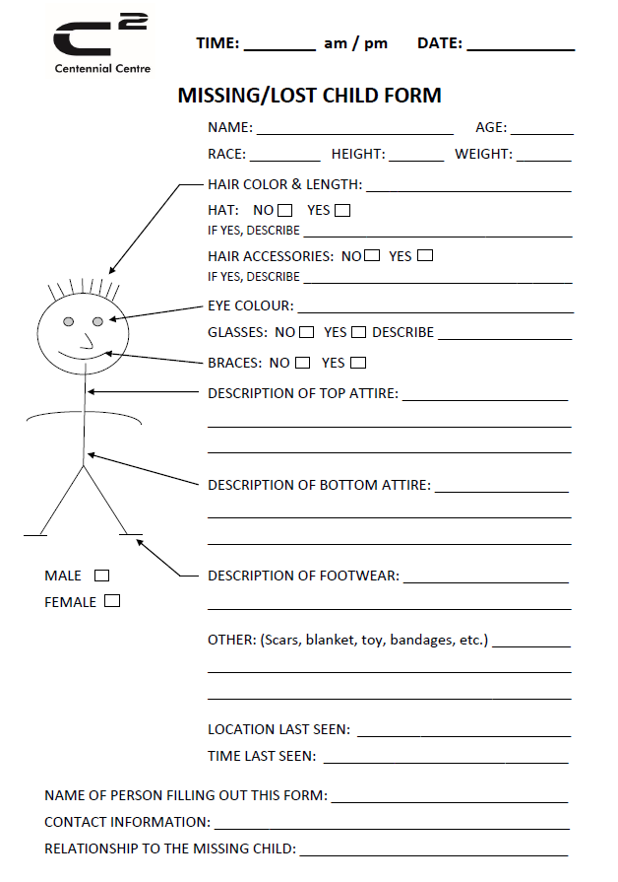

ROBBERY PROCEDURE
- IF AN INDIVIDUAL COMES UP TO YOU with the intent to rob the C2, do not resist. The money is not worth risking a life. Take no action that would jeopardize the safety of anyone. Cooperate with the robber and do not try to become a hero. In most situations, robbers almost never hurt anyone who cooperates.
- TRY TO INFORM THE ROBBER of any surprises. If someone is expected back soon or if you must reach or move in any way, tell the robber what to expect so they will not be startled. A suspicious move by an employee may trigger a violent reaction endangering the lives of many people.
- FOLLOW THE ROBBER’S COMMANDS, but do not volunteer to help. The longer the robbery takes, the more nervous the robber may become and more apt to become violent.
- IF THE ROBBER DEMANDS a specific amount of money, only give them the amount they demand.
- STAY CALM.
- If THE ROBBER DISPLAYS a firearm or claims to have one, consider it loaded and that they would use it.
- ACTIVATE THE PANIC ALARM only if it can be safely done without being obvious to the robber. They are located by Till #1 and Till #2 at the Welcome Desk.
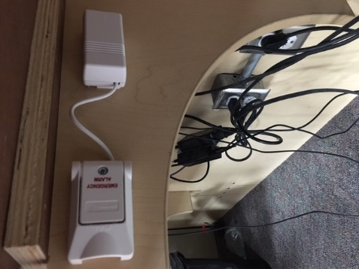

- BE OBSERVANT. Plan to be a good witness. Try to notice as much as possible about the robber.
- Make mental notes of the following:
  - The number of robbers.
  - The robber’s physical characteristics including height, weight, facial characteristics, speech patterns, scars, marks and/or deformities, right or left-handed. Height can be judged by using this measurement tool on the doors:
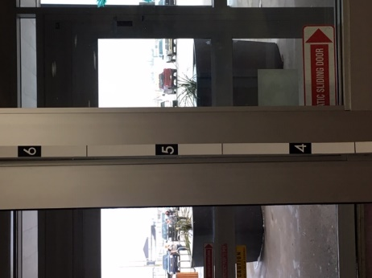
  - The robber’s clothing description.
  - Any names used by the robbers.
  - Any peculiarities exhibited by the robber (i.e., smelled of alcohol, appeared to be “high” on drugs, etc.).
  - Description of any weapons used. Try to notice barrel length, barrel color, color of grips, whether a pistol is automatic or a revolver.
  - If the robber uses a written note, try to place it out of sight to retain it as evidence.
  - After the robber has the money, offer to have employees and customers lie down instead of waiting for the robber to decide what to do, such as knocking you down or tying you up.

- IF THESE STEPS ARE FOLLOWED after a robbery, the business employee will be in a better position to provide information to assist the police in arresting the perpetrator, and more importantly, in protecting the employee and innocent customers from harm.
- DO NOT CHASE OR FOLLOW THE ROBBER. The robber may shoot at any pursuers or the police may shoot at you, too, thinking you are a robber.
- SECURE THE DOORS so the robbers cannot re-enter the C2. Stop business operations and place a sign on the door advising customers that the business is “Temporarily closed due to an emergency.” Do not let anyone in, except emergency personnel.
- DIAL 911 IMMEDIATELY and follow their instructions. The speed of reporting is critical to the apprehension of the offender.
- IF IT CAN BE SAFELY accomplished as the robbers leave, try to note their method of escape along with the direction of travel. If a vehicle is used, try to find out the make, color, type, and license number.
- TRY TO PRESERVE ANY POTENTIAL EVIDENCE. Protect the scene of the crime and do not touch anything the anything the robber may have touched. Keep people out of the area.
- WRITE DOWN EVERYTHING YOU REMEMBER.
- DO NOT DISCUSS THE CRIME until police give permission to do so.

ACTIVE SHOOTER OR LOCKDOWN SITUATION

“Lockdown, Lockdown, Lockdown” will be issued over the PA system and the radios to indicate an active shooter or lockdown situation is at hand.

Hear something? What is going on? Check for crowd reaction.
Trust your intuition. If it sounds like it could be a gun react as though it is.

Planning can save your life. Know your environment.
1. Scan and assess your situation
2. Consider your options

If you believe you can escape, GET OUT safely, and do so immediately.
When you are safe call 911.
Follow the directions of the Police.
1. Choose a safe exit
2. Don’t attract the shooter’s attention
3. Protect yourself first before helping others

If you can’t get out, HIDE in a secure room or space.
Turn off the lights, cover windows, lock the door and barricade it if you can.
Improvise, stay out of the line of fire.
Get under desks or behind tables.
Mute your phone, be quiet, and wait for police to come to you.
1. Turn off lights
2. Lock and barricade door
3. Stay out of the line of fire
4. Be quiet

When you can’t get out and hide, your last resort may be to fight.
This is obviously a worst-case scenario, and it’s only being mentioned to put it forward for your awareness.
Disarm and incapacitate the shooter anyway you can.
1. Improvise weapons from nearby objects
2. Commit to an aggressive physical attack
3. Stop the threat

If you are safe in your hiding place, stay there and let police come to you.
Do whatever you can to get through this.
Preparedness can save your life.

“C2 Clear, C2 Clear, C2 Clear” will be announced over the PA system and the radios when it is safe to come out.

Ammonia Evacuation Procedure
If there’s a major ammonia leak:

- OPERATIONS STAFF will determine wind direction and will help ensure nobody is directly downwind (& pass this info onto Incident Commander & Senior Welcome Desk staff).
- Remain calm and activate the fire alarm.
- Once THE BUILDING ALARM HAS BEEN ACTIVATED, there will be an automatic response sent to the fire department.
- FACILITY OPERATOR TO CALL 911 TO NOTIFY THEM OF THE AMMONIA LEAK.
- WELCOME DESK TO ANNOUNCE OVER THE P.A. SYSTEM THAT WE HAVE AN AMMONIA LEAK AND NOT TO USE THE MUSTER POINT that is determined to be downwind (or not the South one if there is no wind).
- WELCOME DESK CALL STAFF IN THE FOLLOWING ORDER:
      - Operation Manager Kyle Naylor 1-780-573-4285
      - General Manager Les Parsons 1-780-691-6912
- CLEAR your immediate area. Patrons will leave out the appropriate exit to the Muster Point that is found to be downwind.
- WELCOME DESK GET the emergency procedures and go to the fire Alarm Box to retrieve keys and evacuate the building.
- ALL STAFF MUST REPORT IMMEDIATELY AND CHECK IN AT A (E or N) MUSTER POINT. If there are no managers on shift, one Senior Welcome Desk staff will substitute as Incident Commander until a Manager arrives on site.
- OPERATIONS STAFF will meet the emergency response team at the main entrance of the Centennial Centre and will direct them to the source of the problem.
- ONE STAFF will go to each East & North muster point with a radio.
- WAIT FOR FURTHER INSTRUCTIONS FROM THE FIRE DEPARTMENT at one of the two (East & North) muster points outside the building.
- DO NOT RE-ENTER THE BUILDING FOR ANY REASON until the fire department determines it is safe to do so.


Incident Report (No bodily harm)
PERSON FILLING OUT REPORT
Name: |  | Phone Number:
Facility Member: Staff: Visitor: Other:
TYPE OF INCIDENT
Property Damage Theft Hazard Other: ________________________
INCIDENT DETAILS
Date of Incident: ___________________ Time of Incident: ___________ am or pm

Location of Incident: ___________________________ Police Notified: Yes No

What happened: ____________________________________________________________

______________________________________________________________________________

_____________________________________________________________________________

WITNESSES
Witness #1
Name: |  | Phone Number:
Witness #2
Name: |  | Phone Number:

I confirm that the facts stated here are true and to the best of my knowledge.

___________________________________________ _____________________
Signature of person completing this report Date
INCIDENT FOLLOW-UP (Administration use only)
 | Person |  | Police |  | Staff
 | Witness #1 |  | Witness #2 |  | Others
ACTION TAKEN

_______________________________________________ _____________________
Staff Signature Date
Accident Report (With bodily harm)
PERSON FILLING OUT REPORT
Name: |  | Phone Number:
Facility Member: Staff: Visitor: Other: ____________________________

ACCIDENT DETAILS
Date of Accident: ___________________ Time of Accident: ___________ am or pm

Location of Accident: ______________________________ Police Notified: Yes No

What happened: ____________________________________________________________

______________________________________________________________________________
______________________________________________________________________________

INJURIES - Please include ALL injuries, use back of page if required
Injured Person #1
First Name: |  |  |  |  |  |  | Last Name:
Age: |  |  | Phone Number: |  |  |  |  |  |  |  | Female |  |  |  | Male
Describe Injury:
Was first aid administered? |  |  | Yes | No |  | If yes, by whom?
Was first aid refused? |  |  | Yes | No |  | Was an ambulance called? |  |  |  |  |  |  |  | Yes |  | No
Injured Person #2
First Name: |  |  |  |  |  |  |  | Last Name:
Age: |  |  | Phone Number: |  |  |  |  |  |  |  |  | Female |  |  | Male
Describe Injury:
Was first aid administered? |  |  | Yes | No |  | If yes, by whom?
Was first aid refused? |  |  | Yes | No |  | Was an ambulance called? |  |  |  |  |  |  |  | Yes |  | No

WITNESSES
Witness #1
Name: |  | Phone Number:
Witness #2
Name: |  | Phone Number:
SSES
I confirm that the facts stated here are true and to the best of my knowledge.

_________________________________________________ _____________________
Signature of person completing this report Date

INCIDENT FOLLOW-UP (Administration use only)
 | Person |  | Police |  | Staff
 | Witness #1 |  | Witness #2 |  | Others
ACTION TAKEN

______________________________________ _____________________
Staff Signature Date

